Title of paper
List of authors (form: family name (only the first letter capitalized) followed by initials with no periods after the initials, e.g. J Mucklow^{1,3} and A J Fox ^{1,2})
Author addresses
Type the corresponding author’s e-mail address here (e.g. E-mail: jacky.mucklow@iop.org)
Abstract. Start your abstract here… (Should not exceed 200 words in a single paragraph. No table numbers, figure numbers, references or displayed mathematical expressions should be included. )
1 The first section in paper
The first paragraph after a heading is not indented (Bodytext style).
Other paragraphs are indented (BodytextIndented style).
2 Another section of paper
The first paragraph after a heading is not indented (Bodytext style).
Other paragraphs are indented (BodytextIndented style).

2.1 A subsection
Some text.
2.1.1 A subsubsection. Subsubsections end with a full stop (period) and run into the text of the paragraph. The paragraph text follows on from the subsubsection heading but should not be in italic.
References
- A reference
This reference has two entries but the second one is not numbered (it uses the ‘Reference (no number)’ style.
- Aderhold J, Davydov V Yu, Fedler F, Klausing H, Mistele D, Rotter T, Semchinova O, Stemmer J and Graul J 2001 J. Cryst. Growth 222 701
- More references

Layout guide for papers using Microsoft Word

Please, do not add any headers, footers or page numbers to your paper.

Key requirements
Text editor: Microsoft Word version 97 and newer
Page size: A4
Font: Times
Spacing: single line spacing
Margins: 40 mm (top), 25 mm (left and right) and 27 mm (bottom)

Numbering / bullets
Sections should be numbered with a dot following the number and the separated by a single space:
- section should be numbered 1, 2, 3, etc
- subsections should be numbered 2.1, 2.2, 2.3, etc
- subsubsections should be numbered 2.3.1, 2.3.2, etc
Recommended typographical symbol for bullets is Bullet point “•”
Hanging indent for numbering and bullets should be 10 mm.
Figures
Individual figures should normally be centred but place two figures side-by-side if they will fit comfortably like this as it saves space. Place the figure as close as possible after the point where it is first referenced in the text.
Captions should be below the figure and separated from it by a distance of 6 points and should have a full stop (period) at the end. Short captions (up to one line) should be centred. Larger captions should be aligned to the right.
Figures should be numbered sequentially through the text – “Figure 1” and so forth and should be referenced in the text as “figure 1” and not “fig. 1”.

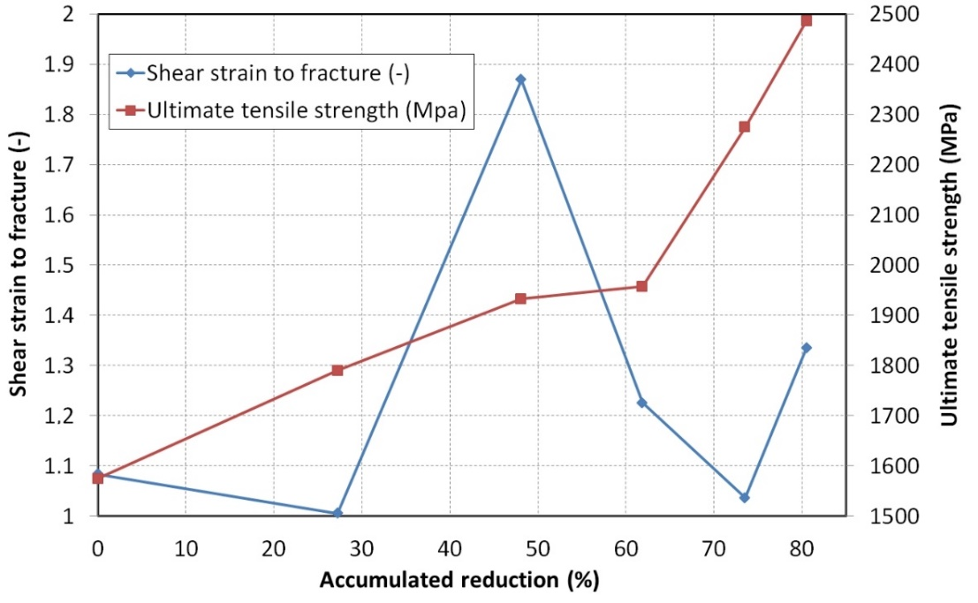

Figure 1. Title of the figure. (Times 11 pt, gaps 6 and 0)
Tables
Tables should be centred unless they occupy the full width of the text. For large tables font sizes can be reduced to make the table fit on a page or fit to the width of the text.
Tables should be numbered sequentially throughout the text and referred to in the text by number (table 1, not tab. 1). Caption should be placed at the top of the table and should have a full stop (period) at the end. Short captions (up to one line) should be centred. Larger captions should be aligned to the left.
Tables should have only horizontal rules and no vertical ones. Generally, only three rules should be used: one at the top of the table, one at the bottom, and one to separate the entries from the column headings.

Table 1. Title of the table. (Times 11 pt, gaps 0 and 6)
 | Wake Chi Sqr. (N=15, df=1) | p | Stage 1 Chi Sqr. (N=15, df=1) | p | Stage 2 Chi Sqr. (N=15, df=1) | p
F3 | 1.143 | 0.285 | 0.286 | 0.593 | 0.286 | 0.593
Fz | 1.143 | 0.285 | 0.067 | 0.796 | 0.067 | 0.796
C4 | 2.571 | 0.109 | 0.600 | 0.439 | 1.667 | 0.197

Equations and mathematics
The preferred style for displayed mathematics is to centre equations (Times 11 pt, gaps 6 and 6); however, long equations that will not fit on one line, or need to be continued on subsequent lines, should start flush left. Any continuation lines in such equations should be indented by 25 mm.
Equations may be numbered sequentially throughout the text (i.e., (1), (2), (3). When referring to an equation in the text, always put the equation number in brackets—e.g. ‘as in equation (2)’ or ‘as in equation (2.1)’—and always spell out the word ‘equation’ in full, e.g. ‘if equation (5) is factorized’; do not use abbreviations such as ‘eqn.’ or ‘eq.’.
Decimal fractions should always be preceded by a zero: for example 0.123 not .123 (note, do not use commas, use the decimal point).
Equations that are referred to in the text should be numbered with the number on the right-hand side.
(1)

Acknowledgements
Any acknowledgements should be placed immediately after the last numbered section of the paper.

References
References should, depending on the type of reference, consist of:
- name(s) and initials (roman);
- date published (roman);
- title of journal, book or other publication (italic);
- titles of journal articles may also be included (optional; roman);
- volume number (bold);
- editors, if any (roman);
- town of publication and publisher in parentheses for books (roman);
- the page numbers (roman).
Point to note:
- the authors should be in the form surname (with only the first letter capitalized) followed by the initials with no periods after the initials. Authors should be separated by a comma except for the last two which should be separated by ‘and’ with no comma preceding it.
- The article title (if given) should be in lower case letters, except for an initial capital, and should follow the date.
- The journal title is in italic and is abbreviated. If a journal has several parts denoted by different letters the part letter should be inserted after the journal in Roman type, e.g. Phys. Rev. A. Please do not join the part letter to the volume number in bold type.
- Both the initial and final page numbers should be given where possible. The final page number should be in the shortest possible form and separated from the initial page number by an en rule ‘– ‘, e.g. 1203–14, i.e. the numbers ‘12’ are not repeated.

Examples:
[1] – preprints, [2] – electronic-only journals, [3 - 6] - books, proceedings and reports.

- Kunze K 2003 T-duality and Penrose limits of spatially homogeneous and inhomogeneous cosmologies Phys. Rev. D 68 063517 (Preprint gr-qc/0303038)
- Horowitz G T and Maldacena J 2004 The black hole final state J. High Energy Phys. JHEP02(2004)008
- Dorman L I 1975 Variations of Galactic Cosmic Rays (Moscow: Moscow State University Press) p 103
- Caplar R and Kulisic P 1973 Proc. Int. Conf. on Nuclear Physics (Munich) vol 1 (Amsterdam: North-Holland/American Elsevier) p 517
- Szytula A and Leciejewicz J 1989 Handbook on the Physics and Chemistry of Rare Earths vol 12, ed K A Gschneidner Jr and L Erwin (Amsterdam: Elsevier) p 133
- Kuhn T 1998 Density matrix theory of coherent ultrafast dynamics Theory of Transport Properties of Semiconductor Nanostructures (Electronic Materials vol 4) ed E Schöll (London: Chapman and Hall) chapter 6 pp 173–214

